**How to Deploy ASP. Net Websites on IIS 7.0**

**Step 2**1 Copy the published **app**lication folder to**"*C:\intepub\wwwroot*"***[TrailBlazer]* folder.

**Step 2**: From **RUN** - > **inetmgr** -> **OK**

The following screen will come. This is the main page for any **app**lication. There are three panels.

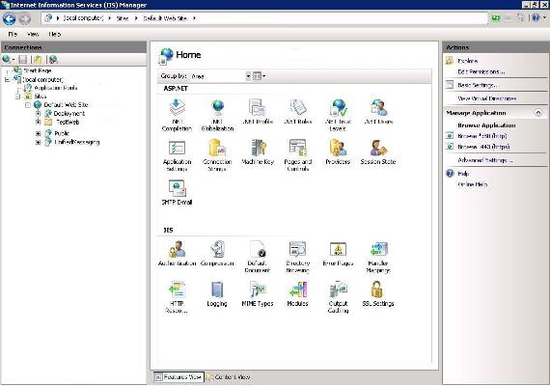

***"TrailBlazer"*** is a recently pasted web**app**lication on your *wwwroot* folder.

**Step 3**: We need to convert it to an **app**lication, just right click and then Click on "ConvertTo**App**lication" as shown in the following picture:

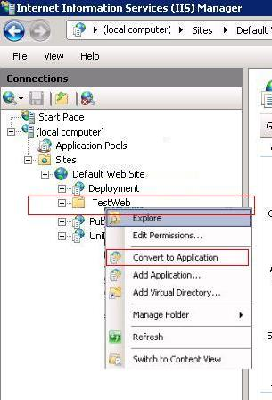

After converting it to **app**lication, its icon will be changed and then you can set the property for your web **app**lication from the middle pane. You can set IIS Authentication Mode, Default Page Just like IIS 6.0:

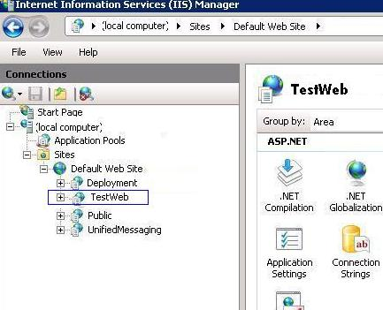

You can change Security Settings on Authentication Section. By default Setting will be set from your *web.config*itself. As in my *web.config* Form Authentication was set that's why, Forms Authentication has been Enabled. If we want to change the status, just double click and update status to Enabled to Disabled or Vice Versa.

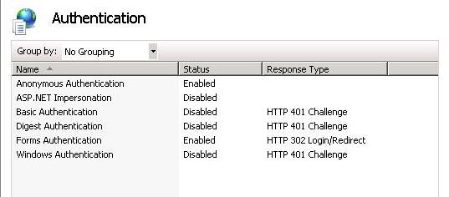

Now one most important part is to set the **App**lication Pool for your **app**lication.

**How to Create Application Pool**

A site can contain many **app**lications including that site’s default **app**lication, which is called the root **app**lication. In addition to belonging to a site, an **app**lication belongs to an **app**lication pool, which isolates the **app**lication from**app**lications in other **app**lication pools on the server .

**Step 1**: Right Click on **App**lication Pool and give the name of your pool. Here, I have given "pool" and select Framework and click on OK:

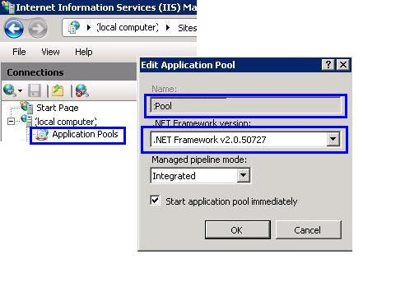

**NOTE – Set the Framework to Version 3.5 for TrailBlazer**

**Step 2**: If you are writing some thing on the server [may be writes Error Events Logs], you need to change the Pool Identity to Local System. Right click on Pool Identity setting as shown in the following image:

There are three identities of **App**lication Pool:

* Network Service
* Local Service
* Local System

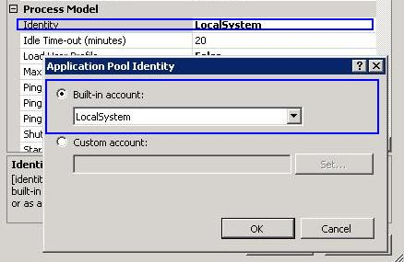

**Assign Application Pool To Your Application**

Now, we need to assign the **App**lication Pool to our web **app**lication.

**Step 1**: Right Click on "TrailBlazer" **App**lication and Select *"Advanced Settings"*:

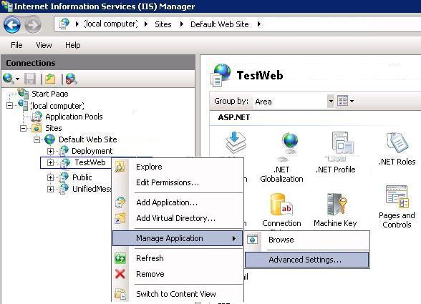

**Step 2**: Finally assign your created **App**lication Pool "pool" to "TrailBlazer" **App**lication.

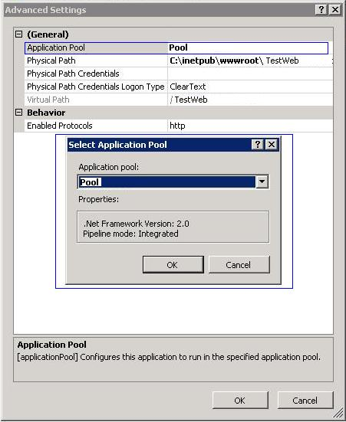

Now you can run your **app**lication by just typing ***http:\\localhost\TrailBlazer*** and it can be accessible on network by IP also.